**Multiplexed 7-Segment Display**

**Engineering 155 Lab II Report**

**September 15th, 2021**

John Hearn

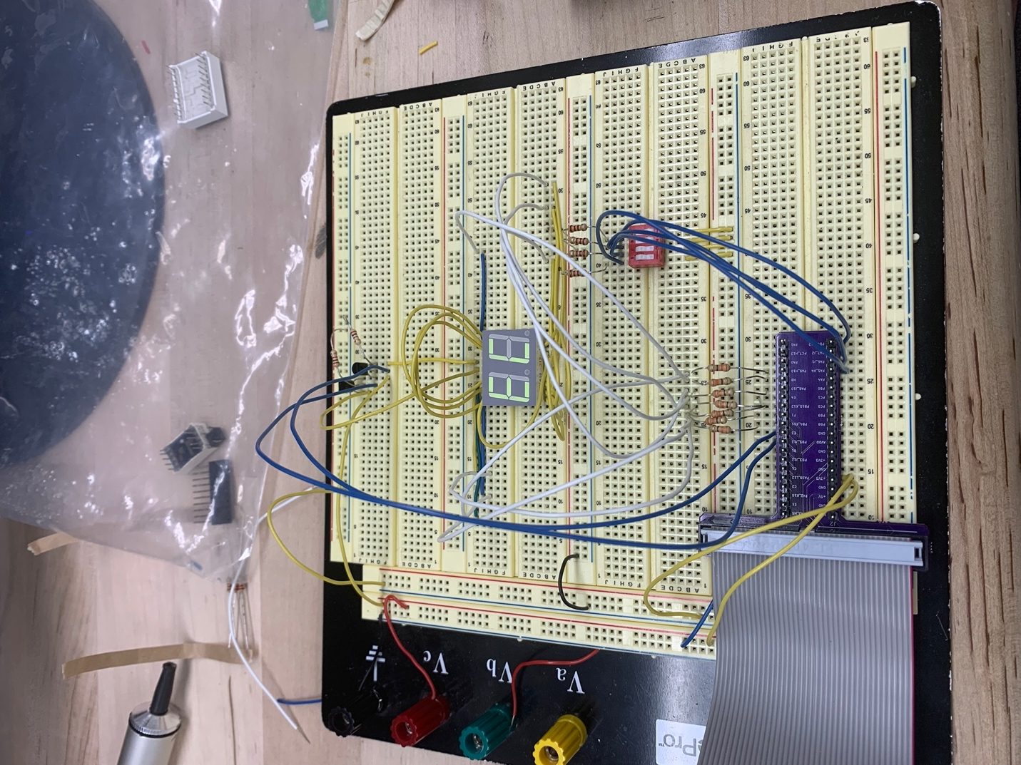

**Introduction:**

The goal of this lab was to implement a time-multiplexing scheme to drive two 7-segment displays with a single set of FPGA I/O pins. We did so by building a simple transistor circuit to amplify the current outputted by the board.

**Design Methodology:**

In designing the hardware for the system, the main point of concern was using the transistors to power both displays and making sure that the resistance in the collector was high enough.

Fig. 1: Resistor calculation

In designing the software, three SystemVerilog modules were created in Quartus. One main module where the calculations for LEDs and which display to power are done, one module to calculate the timing for which display to power (to facilitate the time-multiplexing), and one module to assign the segments high and low.

The system took in three inputs:

**clk** (board’s internal 12MHz clock),

**s1** (board-mounted DIP switches),

**s2** (breadboard-mounted DIP switches)

and had four outputs:

**anode1** (logic to power display 1),

**anode2** (logic to power display 2),

**led** (LED outputs),

**seg** (indicates which segments to power)

It was decided that the displays should run at 1000Hz and using a divide-by-2N counter this feature was made possible. Using the equation fout = fclk * (p / 2N), it was found that the combination of p = 89485, N = 30 gives an accurate approximation of 1000Hz.

**Technical Documentation:**

Fig. 2: SystemVerilog code

Fig. 3: RTL schematic showing logic elements

Fig. 4: Pin placements

Fig. 5: Circuit schematic

**Results and Discussion:**

I was successful in building a time-multiplexed 7-segment display. However, at the time of writing I am running into issues with certain segments not lighting up properly in certain cases. All segments will light up with certain cases. Otherwise, the LEDs are adding up properly and the display is seamless.

If I were to redo this lab I would first refresh myself on the function of transistors and draw a circuit schematic before anything else.

**Conclusion:**

I feel that I was successful in completing all tasks and may have been limited by the board I was testing with. The system works as intended except for a few cases on the display, which I’m unsure is a problem with my wiring or with internal issues with the board.

This lab took roughly 15 hours to complete. A little more instruction would have been nice, but I’m sure that the point of this lab was to get us to start thinking independently more.